Day-31 [Python] Smart Expense Analyzer
Objective
Use Python operators (arithmetic, comparison, logical, and assignment) to analyze a user's monthly expenses and determine financial status.
Problem Statement
You are given the following data:
salary = 50000 rent = 12000 food = 8000 transport = 3000 entertainment = 4000
Tasks
Task 1: Total Expenses
Use arithmetic operators to calculate total expenses.
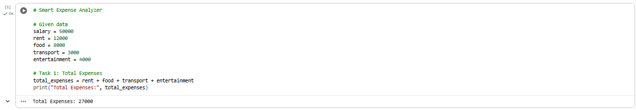

Task 2: Savings Calculation
Calculate savings using:
savings = salary - total_expenses

Task 3: Expense Comparison
  - Check: Is rent greater than food expense?
  - Is transport less than entertainment?
  - Use comparison operators.

Task 4: Financial Condition Check
If savings:
o Greater than 10,000 → "Good Saving"
o Between 5,000 and 10,000 → "Average Saving"
o Less than 5,000 → "Low Saving"
Use logical operators (and, or). 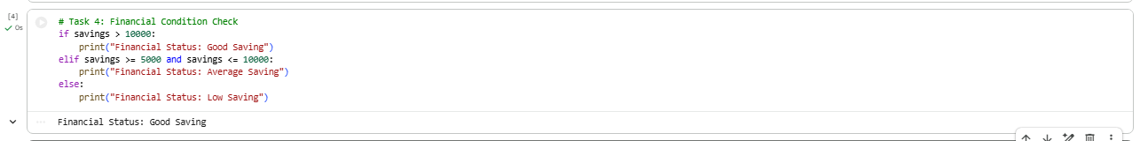
Task 5: Bonus Update
• Increase salary by 10% using assignment operators: salary += salary * 0.10

